Using a Breast Pump

Some mothers are unable to exclusively breast feed their children, and so they may use a breast pump. Even a little bit of breast milk is great.

Breast pumps may be available at the local W.I.C. office, if the mother is getting W.I.C. during pregnancy.

Before using a breast pump for the first time, make sure all the parts are there, which should be shown in the manual. Some breast pumps will ask to boil the non-electric parts before the first use. When the parts are clean, allow them to air dry on a clean towel or paper towel.

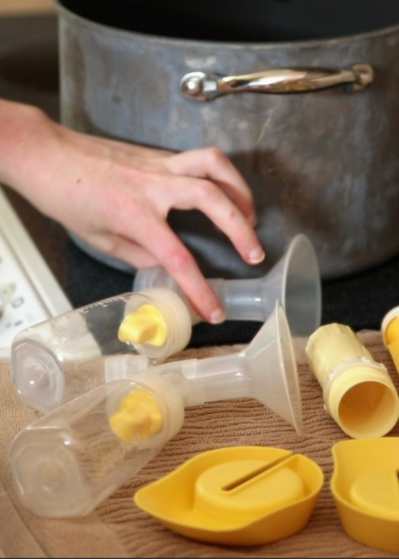
The ways to assemble your breast pump will vary by model, but most electric pumps will come with:

A connector
Valve
Breast Shields
And tubing

The tubes should attach to the breast pump itself, which is how the pump will create suction. Plug the pump into the wall or battery pack and it is ready to use!

Choose the highest suction level which is comfortable. Pumping should not hurt.
Place the breast shield directly over the nipple, and turn on the pump. Do not press hard into the breast. If there is pain while pumping, contact W.I.C. or the mother’s care provider.
When you have finished pumping, prepare your milk for storage.

